It should be a model specially designed and produced for lead aprons.
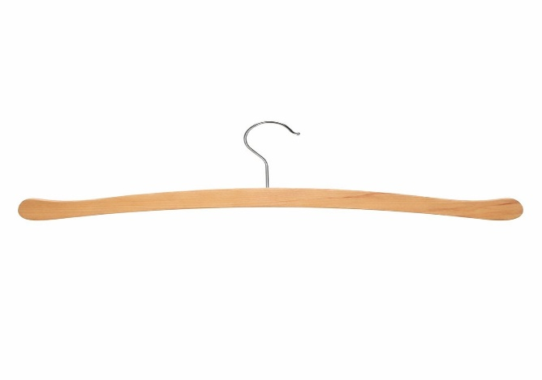

- It should be a model specially designed and produced for lead aprons.
- It must be manufactured with a capacity to carry a lead apron.
- It must be of wooden construction, durable and suitable for hospital use.
- It must be ISO 9001:2008 quality certified.

